01) Write a C code to implement a stack and implements the those functionalities.

* push() - This Function used to insert an element into a stack.
* pop() - This Function used to delete an element from a stack
* isEmpty() - This Function used to find the stack is empty or not.
* isFull() - This Function used to find the stack is full or not.
* getSize() -This Function used to get the size of the stack.
* outPut() - This Function used to print the element of the stack

02) Write a C Program to reverse a String.

Example :

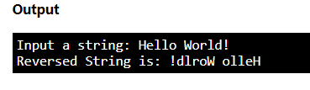

03) Write the C programme to find the given string **palindrome or not?**

**Example :**

**Input a string : MADAM  
Reverse string : MADAM**

**Output : This string is palindrome.**

**Input a string : MOTHER  
Reverse string : REHTOM**

**Output : This string is not a palindrome.**